Spos
Unit – 5
Q. Write a short note on following with example?
A semaphore is a synchronization primitive used in concurrent programming to control access to a common resource by multiple processes or threads [1]. It is essentially an integer variable that is accessed through two standard operations: wait (also known as P or down) and signal (also known as V or up) [1].
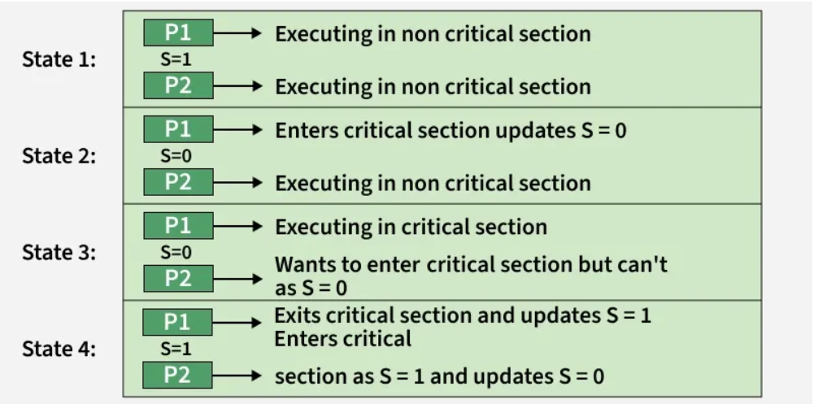
Semaphores are primarily used to prevent race conditions and ensure that critical sections of code are executed by only one process at a time, or by a limited number of processes, depending on the semaphore's initial value [1].

Types of Semaphores:
- Binary Semaphore: Can only have a value of 0 or 1, and is often used as a mutex (mutual exclusion) lock to protect a single resource [1].
- Counting Semaphore: Can have an integer value greater than one, and is used to control access to a resource that has multiple instances available (e.g., a limited number of printer connections) [1].
Example:
Consider a system with five philosophers sitting around a circular table, each with a plate of food. There are five forks placed between adjacent philosophers [1]. Each philosopher needs two forks to eat.
Using a semaphore for each fork prevents two adjacent philosophers from attempting to use the same fork simultaneously, which would lead to a deadlock or a race condition [1].
- Initialization: Five semaphores are created, one for each fork, and each is initialized to 1 (available) [1].
- Wait operation: When a philosopher wants to pick up a left fork, they perform a wait operation on the corresponding semaphore. If the value is 1, it becomes 0 (unavailable), and they pick up the fork. If the value is 0, they must wait until it becomes 1 [1].
- Signal operation: After eating, the philosopher performs a signal operation on both the left and right fork semaphores, making them available again for others to use [1].
This mechanism ensures ordered access and helps manage shared resources effectively in a multi-process environment [1].

ii) Monitor
A monitor is a high-level, synchronization construct that simplifies concurrent programming by encapsulating shared data structures, the procedures (methods) that operate on them, and the synchronization logic into a single module. It guarantees that only one thread can be actively executing any of its methods at any given time, thereby ensuring mutual exclusion automatically.
Key Features
- Encapsulation: It groups shared variables and the functions that access them, hiding internal synchronization mechanisms from the programmer.
- Automatic Mutual Exclusion: The compiler/runtime system handles locking, ensuring that race conditions are prevented without explicit lock/unlock calls by the developer, which makes it less error-prone than using low-level primitives like semaphores.
- Condition Variables: Monitors use condition variables (e.g., wait(), notify(), notifyAll() in Java) to allow threads to temporarily give up exclusive access and wait for a specific condition (e.g., a buffer not being full) to become true. Another thread can then enter the monitor and signal the condition when it changes.
Example: A Bank Account
A common example is a BankAccount monitor where multiple threads might try to deposit or withdraw money simultaneously. Using a monitor ensures these operations happen sequentially and consistently.
Example :
public class BankAccount {
private int balance = 0;

// The 'synchronized' keyword makes this method part of the monitor
public synchronized void deposit(int amount) {
balance += amount;
System.out.println("Deposited: " + amount + ", New Balance: " + balance);
// notify all waiting threads that the balance has changed
notifyAll();
}

// The 'synchronized' keyword makes this method part of the monitor
public synchronized void withdraw(int amount) throws InterruptedException {
// Wait if there are insufficient funds
while (balance < amount) {
System.out.println("Insufficient funds. Waiting for a deposit...");
// Releases the lock and waits for a notification (signal)
wait();
}
balance -= amount;
System.out.println("Withdrew: " + amount + ", New Balance: " + balance);
}
}
In this Java example, the synchronized methods act as the monitor. If one thread calls deposit, any other thread attempting to call deposit or withdraw will automatically block until the first thread finishes. The wait() and notifyAll() methods are used to coordinate between threads when a specific condition (sufficient funds) needs to be met.
iii) Mutex
A mutex (mutual exclusion) is a synchronization primitive used in concurrent programming to prevent race conditions when multiple threads or processes need access to a shared resource [1]. It ensures that only one thread can be in a critical section (the code that accesses the shared resource) at any given time, thereby protecting the integrity of the data [1, 2].
Key Concepts
- Locking and Unlocking: A thread must acquire (lock) the mutex before entering the critical section. If another thread already holds the lock, the current thread will be blocked until the mutex is released (unlocked) [2, 3]. Once the thread finishes with the shared resource, it releases the mutex, allowing another waiting thread to acquire it [3].
- Mutual Exclusion: This is the core principle, ensuring that access to the shared resource is serialized, preventing simultaneous access that could lead to data corruption [1].
- Ownership: Mutexes generally support the concept of ownership, meaning only the thread that locked the mutex can unlock it. This helps prevent accidental unlocks by other threads [3].
Example
Consider two threads, Thread 1 and Thread 2, both trying to increment a shared counter variable in a banking application.
Without a Mutex:
- Counter starts at 100.
- Thread 1 reads Counter (100).
- Context Switch.
- Thread 2 reads Counter (100).
- Thread 2 increments Counter locally (101) and writes it back (Counter becomes 101).
- Context Switch.
- Thread 1 increments its locally read value (101) and writes it back (Counter becomes 101).
The expected final value should be 102, but due to the race condition, the result is 101 [1].
With a Mutex:
- Counter starts at 100.
- Thread 1 acquires the mutex lock.
- Thread 1 reads Counter (100), increments it locally (101), and writes it back (Counter becomes 101).
- Thread 1 releases the mutex lock.
- Context Switch (or Thread 2 attempts to lock the mutex).
- Thread 2 is blocked from entering the critical section because the mutex is locked.
- Thread 2 eventually acquires the mutex lock (once Thread 1 has released it).
- Thread 2 reads Counter (101), increments it locally (102), and writes it back (Counter becomes 102).
- Thread 2 releases the mutex lock.
The final value is correctly 102 because the mutex ensured that only one thread accessed the shared counter at a time [1, 2].
Q. What is Deadlock? Explain deadlock avoidance algorithm with suitable example.
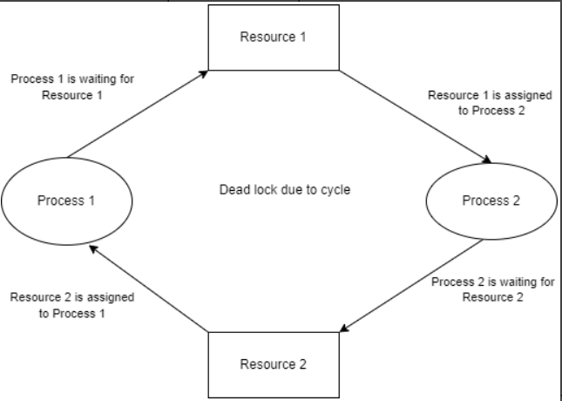
A Deadlock is a situation where processes get stuck, each waiting for a resource held by another in a circular chain, preventing any from progressing, like two cars in a narrow road blocking each other. A Deadlock Avoidance algorithm, like the Banker's Algorithm, prevents this by ensuring the system stays in a "safe state," checking if granting a resource request leads to a potential deadlock before allocation, by tracking maximum needs, available resources, and allocating only if a sequence exists for all processes to finish.
What is Deadlock?
It's a standstill in computing where a group of processes (P1, P2, etc.) are indefinitely blocked because P1 needs a resource held by P2, P2 needs one from P3, and so on, with the last process needing a resource from P1, forming a <</circular wait.
Real-World Example: Two people (processes) trying to pass in a narrow hallway (resource). Each waits for the other to move first, creating a deadlock.
Methods for Handling Deadlock :
There are four methods for handling Deadlock:
- Deadlock Prevention
- Deadlock Avoidance
- Deadlock Detection
- Deadlock Recovery
Deadlock Avoidance: Banker's Algorithm
This algorithm prevents deadlock by ensuring the system remains in a "safe state".
- Core Idea: Before allocating resources, the OS checks if it's safe to do so. A state is "safe" if there's some sequence in which all processes can finish, even if they all request their maximum resources.
How it Works (Simplified Steps):
- Know Max Needs: The OS knows the maximum resources each process might ever need.
- Track Resources: Keep track of {Total Resources}, {Resources Allocated}, and {Resources Available}.
- Check for Safety: When a process requests resources:
  - Assume the request is granted (temporarily).
  - Calculate {Available} - {Requested}.
  - Check if the remaining {Available} + {Allocated} can satisfy some process's remaining needs (Max - Allocated).
  - If yes, find another process that can finish, release its resources, and repeat.
  - If all processes can eventually finish in some order, the state is safe, and the allocation is granted.
  - If not, the request is denied (the process waits), and the system stays in its current safe state.
Example:
- Processes: P1, P2, P3
- Resources: 10 'R' units total (e.g., memory blocks)
- State:
  - P1 holds 2, Max needs 5 (Needs 3 more)
  - P2 holds 3, Max needs 7 (Needs 4 more)
  - P3 holds 1, Max needs 4 (Needs 3 more)
  - Available: 10 - (2+3+1) = 4 units.
- Request: P1 requests 2 more units.
- Safety Check:
  - If P1 gets 2, Available becomes 2. P1 needs 3, so P1 can't finish.
  - But wait, P3 needs 3. With 2 Available, P3 can't finish.
  - P2 needs 4. Can't finish.
  - Hmm, maybe not safe if P1 gets it. Let's see if P3 can finish first (needs 3, has 4 available): Yes.
  - If P3 finishes, it releases its 1 + P1's 2 + P2's 3 = 6 units. Now Available is 4 + 6 = 10. All processes can finish.
  - Wait! The check is different: Does granting P1's current request (2 units) leave us safe?
  - New Available: 4 - 2 = 2. P1 needs 3 (can't finish). P3 needs 3 (can't finish). P2 needs 4 (can't finish).
  - Conclusion: Granting P1's request leads to an unsafe state where no one can finish. Deny P1's request, and P1 waits.
Q. Explain hardware approach for Mutual Exclusion with its advantages and disadvantages
Hardware approaches for mutual exclusion use special CPU instructions (like Test-and-Set, Swap) or interrupt disabling, providing fast, atomic operations to protect critical sections, guaranteeing only one process accesses shared data; however, they often suffer from CPU wastage due to busy-waiting (Test-and-Set) or can't work in multiprocessor systems (interrupts), leading to inefficiencies or complex solutions.
Hardware Approaches Explained
- Interrupt Control (Uniprocessor)
  - How it works: The CPU disables all interrupts before entering a critical section and re-enables them afterward, preventing preemption.
  - Pros: Simple, guarantees mutual exclusion on single-core systems.
  - Cons: Inefficient for long critical sections (missed timer interrupts, clock drift), doesn't work on multiprocessors.
- Test and Set Lock (TSL) (Atomic Instruction)
  - How it works: A single hardware instruction reads a memory location (lock) and sets it to a new value (e.g., true) in one indivisible (atomic) step, ensuring no interruption.
  - Pros: Simple to implement, faster than software locks, works in multiprocessor systems.
  - Cons: Uses busy-waiting (spinlock), wasting CPU cycles as processes repeatedly check the lock.
- Swap (Exchange) (Atomic Instruction)
  - How it works: Exchanges the contents of two memory locations atomically, often used with a lock variable and a key variable to acquire/release locks.
  - Pros: Also atomic, prevents race conditions.
  - Cons: Still prone to busy-waiting, similar to TSL.
Advantages & Disadvantages Summary
- Advantages:
  - Speed: Hardware instructions execute very quickly.
  - Atomicity: Guarantees operations are indivisible, preventing race conditions.
  - Simplicity (Relative): Provides lower-level primitives for synchronization.
- Disadvantages:
  - Busy-Waiting: Many hardware methods (TSL, Swap) cause CPU wastage.
  - Complexity in Multiprocessors: Interrupt-based methods fail; TSL/Swap can have high contention.
  - Starvation: Can occur if processes repeatedly lose the race for the lock.
Q. What is semaphore? Write a solution to Reader Writer problem using Semaphore with Readers have priority
A Semaphore is a signaling mechanism for process synchronization, controlling access to shared resources with wait() (P) and signal() (V) operations, allowing only authorized processes to enter critical sections. For the Readers-Priority solution to the Readers-Writers Problem, we use wrt (write) for database access, mutex for updating reader count, and readCount (integer) to track active readers; the first reader locks wrt, blocking writers, while subsequent readers pass, and the last reader unlocks wrt, preventing writer starvation by letting readers in as long as one is reading, ensuring readers always get priority.
Semaphore Definition
- Semaphore: An integer variable used for synchronization, accessed only through atomic wait() (P) and signal() (V) operations.
  - wait(S): Decrements S; if S < 0, process blocks.
  - signal(S): Increments S; if processes are blocked on S, one is woken up.
Readers-Writers Problem (Readers Priority)
This solution allows multiple readers but only one writer, prioritizing readers so they don't wait if readers are already present, potentially starving writers.
Variables & Semaphores:
- readCount: Integer, initialized to 0 (tracks active readers).
- mutex: Binary semaphore, initialized to 1 (protects readCount).
- wrt: Binary semaphore, initialized to 1 (controls access to the shared database).
Reader Process Logic:
// Reader Process
P(mutex); // Lock for updating readCount
readCount++;
if (readCount == 1) { // First reader
P(wrt); // Lock the database from writers
}
V(mutex); // Unlock readCount

// --- Reading is performed here ---
// Read the shared resource (multiple readers can be here)
// ---------------------------------

P(mutex); // Lock for updating readCount
readCount--;
if (readCount == 0) { // Last reader
V(wrt); // Unlock the database for writers
}
V(mutex); // Unlock readCount
Writer Process Logic:
// Writer Process
P(wrt); // Wait for exclusive access to the database
// --- Writing is performed here ---
// Write to the shared resource (only one writer allowed)
// ---------------------------------
V(wrt); // Release exclusive access
How it Works (Reader Priority):
- First Reader In: The first reader acquires mutex, increments readCount to 1, then performs P(wrt), blocking any waiting or new writers.
- Subsequent Readers: Other readers acquire mutex, increment readCount, but skip the P(wrt) (since readCount > 1), and can read concurrently.
- Writer Arrives: A writer must wait at P(wrt), which is held by the first reader (or another reader/writer).
- Last Reader Out: The last reader decrements readCount to 0 and performs V(wrt), allowing a waiting writer (if any) to proceed.
- Writer Exclusive: Writers get exclusive access to the database using P(wrt) and V(wrt).
Q. What is semaphore? Justify how semaphore is used to solve critical section problem.
A semaphore is a synchronization primitive used in concurrent programming to control access to a common resource by multiple processes, preventing race conditions and ensuring proper coordination [1]. It acts as a signaling mechanism, essentially a variable or an abstract data type, used to manage access to a limited number of resources [1].
Components of a Semaphore
A semaphore typically has two main atomic operations:
- Wait (or P, down, acquire): This operation decrements the semaphore's value. If the value becomes negative or zero, the process must wait (block) until another process increments the value [1].
- Signal (or V, up, release): This operation increments the semaphore's value. If there are processes waiting, one of them is unblocked [1].
How Semaphore is Used to Solve the Critical Section Problem
The critical section problem involves designing a protocol that ensures only one process is executing its critical section (the part of the code that accesses shared resources) at any given time [1]. Semaphores provide a simple and effective solution to this problem, ensuring the key conditions of mutual exclusion, progress, and bounded waiting are met [1].
Here is how a binary semaphore (a semaphore that can only be 0 or 1) is used to achieve this:
- Initialization: A binary semaphore, often called mutex (for mutual exclusion), is initialized to a value of 1 [1]. This signifies that the critical section is initially free and available.
- Entering the Critical Section:
  - Before entering the critical section, a process performs a Wait operation on the mutex semaphore [1].
  - The Wait operation decrements mutex from 1 to 0.
  - Since the value is non-negative, the process is allowed to proceed and enters the critical section [1].
- Mutual Exclusion:
  - If another process attempts to enter the critical section while the first process is inside, it will also perform a Wait operation [1].
  - This second Wait operation attempts to decrement mutex from 0 to -1.
  - Because the value is now negative, the second process is blocked and placed in a waiting queue [1].
  - This guarantees that only one process is executing the critical section at any given time [1].
- Exiting the Critical Section:
  - When the first process finishes its work in the critical section, it performs a Signal operation on the mutex [1].
  - The Signal operation increments mutex from 0 back to 1.
  - If there are processes waiting in the queue (as in the example above), one of them is released from the blocked state and can now enter its critical section, ensuring progress [1].
By using Wait operations before the critical section and Signal operations after, the semaphore acts as a gatekeeper, enforcing the rules of concurrent access and solving the critical section problem [1].
Q. Explain necessary conditions for occurrence of deadlock.
For a deadlock to occur, four conditions—Mutual Exclusion, Hold and Wait, No Preemption, and Circular Wait—must all be met simultaneously, forming the basis of the Coffman conditions, where processes are stuck waiting for resources held by each other in a closed loop.
Here are the four necessary conditions in detail:
- Mutual Exclusion: Resources are non-shareable; only one process can use a resource at a time. If another process needs the resource, it must wait until it's released.
- Hold and Wait: A process holds at least one resource while waiting to acquire additional resources held by other processes.
- No Preemption: Resources cannot be forcibly taken away (preempted) from a process; they must be released voluntarily by the process holding them.
- Circular Wait: A chain of processes exists where each process holds a resource needed by the next process in the chain, forming a closed loop.
If any one of these conditions is absent, a deadlock cannot occur.
Q.Explain Deadlock prevention, deadlock avoidance, deadlock detection, deadlock recovery with example?
Deadlock handling involves Prevention (breaking circular wait via strict rules like all-or-nothing requests), Avoidance (Banker's Algorithm dynamically checking for safe states), Detection (finding deadlocks with wait-for graphs/cycle detection), and Recovery (killing processes or preempting resources to break the deadlock). For example, a printer/scanner deadlock (Process A holds Printer, waits for Scanner; Process B holds Scanner, waits for Printer) can be prevented by A requesting both at once, avoided by checking if granting resources keeps the system safe, detected by finding a cycle in a resource graph, or recovered by killing A or B.

1. Deadlock Prevention (Proactive)
Ensures at least one of the four deadlock conditions (Mutual Exclusion, Hold & Wait, No Preemption, Circular Wait) can never occur.
- Method:
Break the Circular Wait condition by imposing order. Processes request all resources at once or release all held resources to request new ones.
- Example:
A process needing a printer and a scanner must request both simultaneously; it can't hold one while waiting for the other.
- Downside:
Poor resource utilization (resources sit idle) and reduced system performance.
This video explains the concept of deadlock prevention:
2. Deadlock Avoidance (Proactive/Dynamic)
Dynamically checks if granting a resource request leads to an unsafe state (potential deadlock).
- Method:
Uses algorithms like the Banker's Algorithm, requiring processes to declare maximum resource needs upfront.
- Example:
If Process A needs 4 units, B needs 3, and only 3 are available, the system checks if granting A's request leaves enough for B to finish safely. If not, A waits.
- Downside:
Requires full knowledge of future resource needs, which isn't always possible, and adds runtime overhead.
3. Deadlock Detection (Reactive)
Allows deadlocks to occur and then finds them.
- Method: Periodically runs algorithms to check for cycles in the Resource Allocation Graph (or Wait-For Graph for single-instance resources).
- Example: If P1 waits for P2, and P2 waits for P1 (a cycle), detection identifies this deadlock.
- Benefit: Better resource utilization than prevention/avoidance.
4. Deadlock Recovery (Reactive)
Resolves detected deadlocks.
- Methods:
  - Process Termination: Kill one or all deadlocked processes.
  - Resource Preemption: Take resources from a process, potentially rolling it back to a safe state.
- Example: Kill Process P1 (which holds a printer) to free the printer for P2, allowing P2 to finish and release its scanner for P1 (if it held one).
- Downside: Data loss or system inconsistency from process termination.

Q. Explain producer Consumer problem & Dining Philosopher problem with solution?
Producer-Consumer Problem :
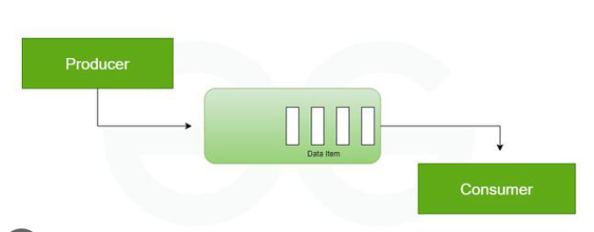
The Producer-Consumer Problem is about a Producer (creates data) and a Consumer (uses data) sharing a fixed-size buffer (like a box). The problem is preventing the Producer from adding to a full box and the Consumer from taking from an empty box, plus ensuring they don't mess with each other simultaneously; the solution involves semaphores/mutexes to manage access, making them wait (sleep) when `conditions aren't right, ensuring smooth, synchronized data flow.

The Problem (Analogy: A Small Basket)
- Producer: A baker making cookies (data) and putting them in a basket (buffer).
- Consumer: A customer taking cookies from the basket.
- Fixed Buffer: The basket can only hold, say, 10 cookies.
- The Issues:
  - Full Buffer: If the basket has 10 cookies, the baker must wait for the customer to take one before adding more.
  - Empty Buffer: If the basket is empty, the customer must wait for the baker to make and add a cookie.
  - Simultaneous Access: The baker and customer can't both be reaching into the basket at the exact same time (a race condition).
The Solution (Using Semaphores/Mutexes)
Solutions use synchronization tools (like semaphores) to control access:
- Mutex (Mutual Exclusion): A lock ensuring only one person (Producer or Consumer) touches the basket at any moment to prevent chaos.
This coordination ensures safety, preventing data loss or incorrect states, making it a fundamental concept in operating systems for managing shared resources.

Dining Philosophers Problem :
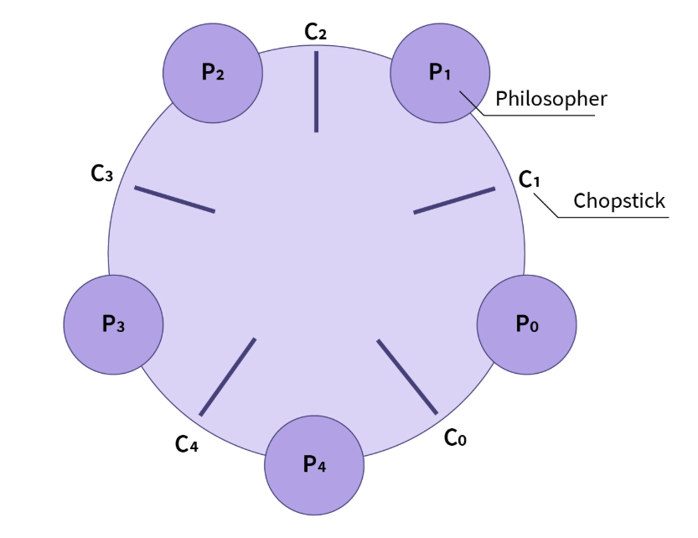
The Dining Philosophers Problem illustrates resource contention and deadlock in concurrent systems: five philosophers around a table need two chopsticks (shared resources) to eat, but only five exist, one between each pair, creating circular waiting if all grab their left chopstick, causing a standstill (deadlock) where none can eat. Solutions involve breaking this circular wait, like resource hierarchy (ordered chopstick pickup), using a waiter/monitor, or an asymmetric approach (one philosopher picks right first), ensuring fair access and preventing indefinite waiting (starvation).
The Problem Explained
- Scenario: 5 Philosophers (P0-P4), 5 Chopsticks (C0-C4).
- Goal: Think and Eat.
- Constraint: Need two adjacent chopsticks (left & right) to eat.
- The Deadlock: If all philosophers simultaneously pick up their left chopstick, they all wait forever for their right chopstick, which is held by their right neighbor, creating a deadlock.
Solutions (Avoiding Deadlock)
- Resource Hierarchy (Ordering): Assign a global order to chopsticks (e.g., by number). Each philosopher always picks up the lower-numbered chopstick first, then the higher-numbered one. This breaks the circular dependency.
- Waiter/Monitor (Centralized Control): A central entity (waiter/monitor) controls access. Philosophers ask permission to eat; only when both forks are free (or only one at a time) can they proceed, preventing simultaneous grabs.
- Asymmetric Solution: Most philosophers pick up left then right, but one (e.g., the last one) picks up right then left. This disrupts the circular wait.
- Limiting Diners: Allow only 4 philosophers at the table at any time, ensuring at least one has both forks available.
- Conditional Acquisition: A philosopher only picks up both forks as an atomic (indivisible) action; if they can't get both, they put down any they have and wait.
Using Semaphores (A Common Implementation)
- Each Chopstick = A Semaphore: Initialize each of the 5 semaphores to 1 (available).
- Process:
  - Think.
  - Acquire Forks: Wait (decrement) on left chopstick semaphore, then wait (decrement) on right chopstick semaphore (or use ordered/asymmetric logic).
  - Eat.
  - Release Forks: Signal (increment) both semaphores, making them available.
- Key: Using semaphores with one of the above strategies (like the asymmetric one) prevents the deadlock scenario.

Unit – 6
Q.Compare Paging and Segmentation with the help of an example.
An example shows paging splitting a 16KB program into 4KB pages, while segmentation might see it as a 4KB code segment, 8KB data segment, and 4KB stack segment, showing fixed vs. logical, variable-size differences and their respective fragmentation types.
Paging
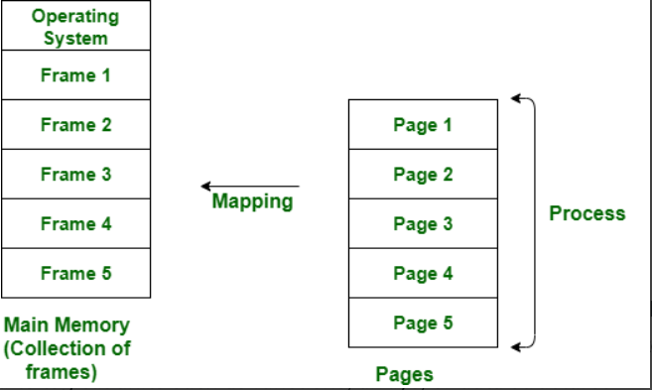
Paging divides memory into fixed-size blocks (pages/frames) for efficient non-contiguous allocation, avoiding external fragmentation but causing internal fragmentation (unused space in the last page).

- Concept: Divides a process into fixed-size chunks (pages) and physical memory into fixed-size frames (pages in main memory).
- Address: Logical address = Page Number + Offset.
- Fragmentation: Suffers from internal fragmentation (unused space in the last page).
- View: Invisible to the user; managed by hardware.
- Example: A 16KB program divided into 4KB pages (4 pages). Main memory (e.g., 64KB) has 16 frames. Pages can be loaded non-contiguously (e.g., Page 1 in Frame 2, Page 2 in Frame 5).
Segmentation
Segmentation divides processes into variable-sized logical units (segments like code, data, stack) based on programmer view, avoiding internal fragmentation but creating external fragmentation (unused small holes between segments).
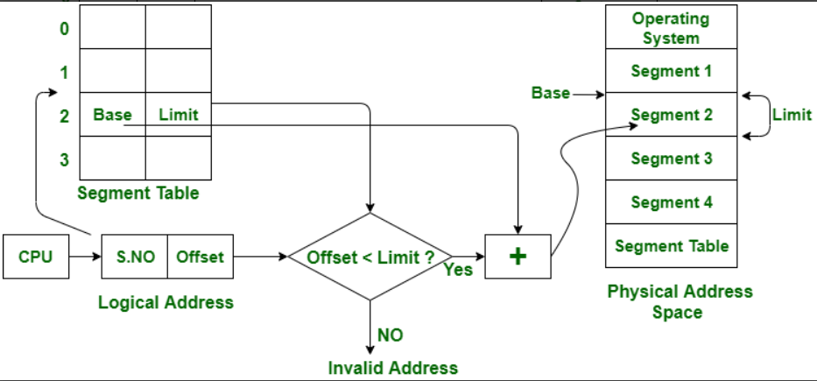
- Concept: Divides a process into variable-sized logical units (segments) like code, data, functions, stack, based on programmer's view.
- Address: Logical address = Segment Number + Offset.
- Fragmentation: Suffers from external fragmentation (small, unusable free memory blocks between segments).
- View: Visible to the user; managed by compiler/OS.
- Example: A 16KB program split into a 4KB code segment, 8KB data segment, and 4KB stack segment. These segments are loaded into available, contiguous memory blocks, which might leave small gaps.

Difference Between Paging and Segmentation

Feature | Paging | Segmentation
Division Unit | Fixed-size pages | Variable-size segments
Managed By | Operating system | Compiler
Unit Size Determined By | Hardware | User/programmer
Address Structure | Page number + page offset | Segment number + segment offset
Data Structure Used | Page table | Segment table
Fragmentation Type | Internal fragmentation | External fragmentation
Speed | Faster | Slower
Programmer Visibility | Invisible to the user | Visible to the user
Sharing | Difficult | Easy
Data Structure Handling | Inefficient | Efficient
Protection | Hard to implement | Easier to apply
Size Constraints | Page = Frame size | No fixed size required
Memory Unit Perspective | Physical unit | Logical unit
System Efficiency | Less efficient | More efficient

Q. What is TLB? Explain the paging system with the use of TLB? What are the advantages of TLB?
A TLB, or Translation Lookaside Buffer, is a hardware cache that speeds up memory access by storing recent translations of virtual addresses to physical addresses. In a paging system, the CPU first checks the TLB for a virtual page number; if found (a TLB hit), the physical frame number is immediately used, avoiding the need to look up the page table in main memory. If the translation is not in the TLB (a TLB miss), the system accesses the page table in main memory, and the new entry is then added to the TLB. The main advantage of using a TLB is the significant reduction in the time it takes to translate addresses, which greatly improves overall system performance by reducing memory access latency.
Paging system with a TLB
- CPU generates a logical address: The CPU needs to access data, which requires a logical address containing a page number and an offset.
- TLB lookup: The CPU's memory management unit (MMU) first checks the TLB to see if the page number is already present.
- TLB Hit: If the page number is found in the TLB, a "hit" occurs. The TLB provides the corresponding physical frame number instantly, which is then combined with the offset to form the physical address.
- TLB Miss: If the page number is not in the TLB, a "miss" occurs.
  - The MMU must then access the full page table, which is located in main memory, to find the physical frame number for that page.
  - This slower access retrieves the required frame number, which is then used to form the physical address.
  - The new page number and frame number pair is also added to the TLB, replacing an older entry, for faster access to this translation in the future.

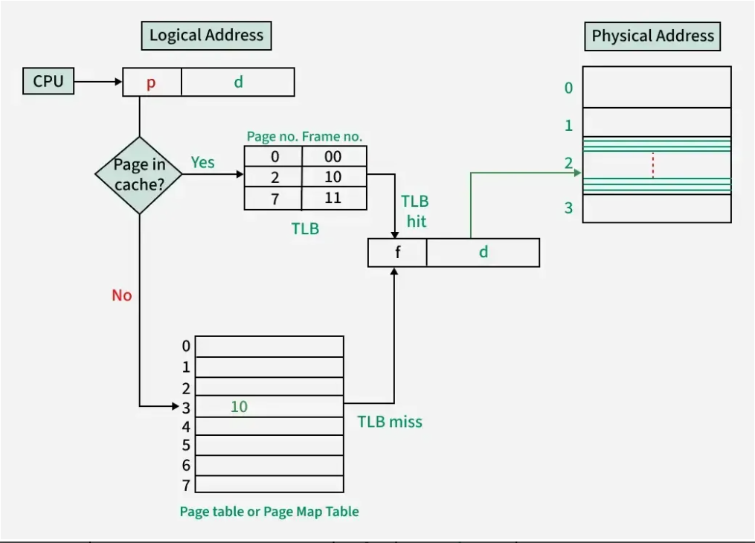
Translation Lookaside Buffer (TLB) in Paging

Advantages of using a TLB
- Increased speed: The TLB significantly reduces the time required for address translation because checking the TLB is much faster than accessing main memory.
- Improved performance: By providing quick access to recently used translations, the TLB minimizes the number of memory accesses needed for address translation, which leads to a higher overall system performance.
- Reduced latency: It helps to overcome the latency introduced by paging, which requires an extra memory access for every translation when not using a TLB.
Q. What is internal fragmentation? Explain same with suitable diagram/ example.
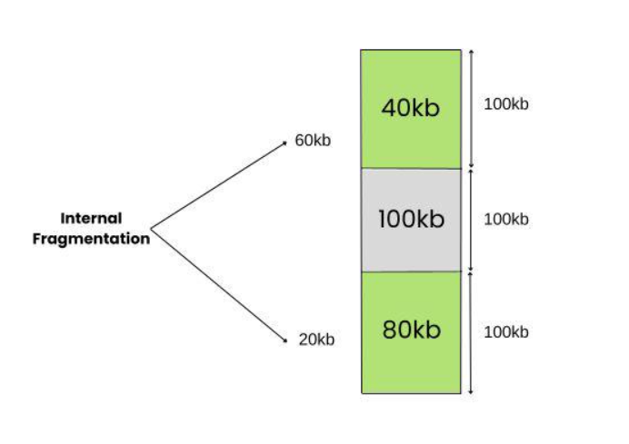
Internal Fragmentation is the wastage of memory that occurs when fixed-sized memory blocks are allocated to processes, but the process does not use the entire allocated block. The unused portion inside the allocated block remains idle, resulting in poor memory utilization.

How Internal Fragmentation is Caused?
- Fixed Block Allocation: When processes request memory, they are often assigned blocks larger than required. The unused space within the block is wasted.
- Uniform Block Sizes: If all processes get the same memory size, smaller processes leave large unused portions.
- Management Overheads: Some systems reserve extra memory for bookkeeping, which also adds to internal fragmentation.
Example:
Let's assume that the system that is being used assigns the memory in blocks of sizes being multiples of 4(like 12, 24, 32,..). In this system when a process P1 requests an amount of memory that is not a multiple of 4, it is assigned a memory block of value of the nearest higher multiple.

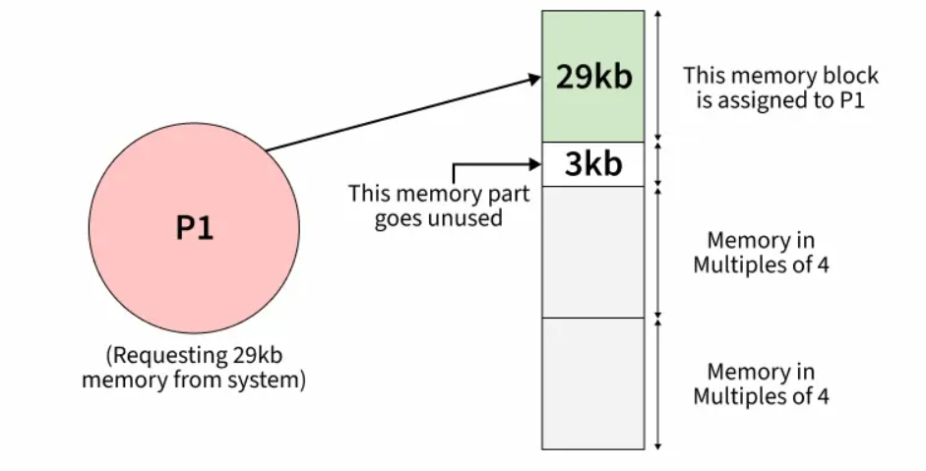
- A process requests 29 KB.
- It will be assigned 32 KB (nearest multiple of 4).
- The extra 3 KB remains unused.
This 3 KB loss is internal fragmentation.
Effect of Internal Fragmentation
Due to Internal Fragmentation various types of effects occurs:
- Inefficient Memory Utilization: Wasted space reduces overall usable memory.
- Performance Degradation: More I/O operations due to scattered partially filled blocks.
- Virtual Memory Issues: Partially filled pages can increase page faults.
Why Internal Fragmentation is Allowed?
- As the allocation always occurs in a fixed size only the allocation becomes fast and simple.
- When the overhead calculation for the system is done it outputs to be pretty predictable which in return gives a predictable performance. The overhead calculation is accurate as the overhead caused by the Internal Fragmentation is already well known.
Ways to Avoid Internal Fragmentation
There are several ways to avoid Internal fragmentation. Some of them are mentioned below.
- Variable-Sized Blocks: Create memory blocks of different sizes and allocate the best-fit block for each process, reducing unused space.
- Dynamic Memory Allocation: Assign only the exact memory required by a process, so little to no memory is wasted.

Q. What is EXternal fragmentation? Explain same with suitable diagram/ example.
External fragmentation is a problem in memory management where free memory is divided into small, non-contiguous blocks. Even though there may be enough total free memory to run a new program, the memory is scattered in tiny pieces, so it's impossible to find a single, large block for the program to use. This leads to wasted memory and poor system performance.
Why Does It Happen?
External fragmentation is caused by the dynamic allocation and deallocation of processes. Imagine memory as a long parking lot.
- A few cars (processes) park in different spots.
- Then, some of these cars leave, creating empty spaces (free memory).
- These empty spaces are of different sizes and are scattered throughout the lot.
- If a new, large truck (a new process) arrives, it can't find a single, continuous space big enough to park, even though the total empty space in the lot is more than enough.
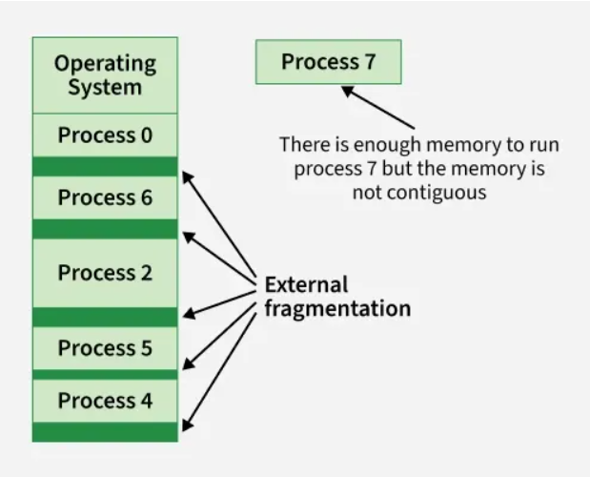
This is exactly how external fragmentation works. The "holes" in the memory are too small and separated to be useful for larger processes.

How to Avoid External Fragmentation?
To avoid external fragmentation in an operating system:
- Paging/Segmentation: Paging allocates memory in fixed-size pages, avoiding external fragmentation. Segmentation uses variable-sized blocks but may still leave some gaps.
- Compaction: Rearranges processes in memory to merge free spaces into larger contiguous blocks.
- Best-Fit Allocation: Assigns the smallest available block that fits a process, reducing wasted space (though not eliminating fragmentation completely).
Causes of External Fragmentation
The primary causes of external fragmentation include:
- Variable Process Sizes: Different processes need different amounts of memory, leaving uneven gaps when loaded/unloaded.
- Allocation & Deallocation: When processes finish, freed blocks may not be adjacent, creating scattered holes.
- Non-Uniform Release: Memory released at irregular points leads to gaps of unpredictable sizes.
- Allocation Strategies: Best-fit and worst-fit may worsen fragmentation by leaving behind many small unusable holes.
- Fixed Partitioning: Fixed-sized partitions cause mismatches between process size and partition size, leading to internal and external fragmentation.
- High Process Turnover: Frequent loading and removal of processes leaves memory fragmented over time.
Solution of External Fragmentation
Below mentioned are the solutions of External Fragmentation that are mentioned below.
1. Memory Compaction
Memory compaction includes rearranging the items in memory to unite free memory hinders and make bigger contiguous memory regions. This is the closely guarded secret:
- Process Relocation: Moves processes closer together to eliminate or reduce gaps, creating larger contiguous free memory blocks.
- Benefits: Directly reduces external fragmentation, increasing the chance of allocating memory without gaps.
- Challenges: Can be resource-intensive, may disrupt running processes, and frequent compaction can impact system performance.
2. Paging
Paging is a memory management technique that divides physical memory into fixed-size blocks called pages. It helps overcome external fragmentation and simplifies memory allocation.
- Page Size: Memory is divided into equal-sized pages, preventing small unusable gaps.
- Virtual Memory: Allows processes to use non-contiguous physical memory while seeing it as a single contiguous space.
- Page Table: The OS maintains a page table that maps virtual addresses to physical addresses.
- Page Replacement: When memory is full, pages can be swapped between main memory and disk to free space.
Q. Write and explain Deadlock Avoidance Bankers Algorithm.
The Banker's Algorithm is an operating system's deadlock avoidance algorithm that ensures a system remains in a safe state by simulating resource allocation before granting a request. A state is safe if all processes can complete their execution in some sequence without causing a deadlock.
Explanation of the Banker's Algorithm
The algorithm is named after the banking system, where a banker never grants a loan if it means they might not be able to satisfy all customers' total potential demands (withdrawals) in the worst case. Similarly, in an OS, the algorithm evaluates every resource request:
- If granting the request results in a safe state, the resources are allocated immediately.
- If granting the request leads to an unsafe state, the process must wait until enough resources are released by other processes.
Key Data Structures
The algorithm uses the following data structures, where 'n' is the number of processes and 'm' is the number of resource types:
- Available: A vector of length 'm' showing the number of available instances of each resource type.
- Max: An n × m matrix defining the maximum demand of each process for each resource type. This must be declared by the process beforehand.
- Allocation: An n × m matrix showing the number of resources of each type currently allocated to each process.
- Need: An n × m matrix indicating the remaining resource need for each process. It is calculated as Need[i][j] = Max[i][j] - Allocation[i][j].
The Safety Algorithm
The core of the Banker's Algorithm is the Safety Algorithm, which determines if a system is in a safe state.
- Initialization:
  - Initialize a Work vector (length 'm') equal to the Available vector.
  - Initialize a Finish vector (length 'n') to false for all processes, meaning no process has finished yet.
- Find a Suitable Process:
  - Find an index i such that both Finish[i] == false and Need[i] <= Work.
  - If no such process exists, go to Step 4.
- Simulate Resource Release:
- If a suitable process Pi is found, it can potentially complete its execution. Mark it as finished and simulate the release of its resources back to the available pool:
      - Work = Work + Allocation[i]
      - Finish[i] = true
- Go back to Step 2 to look for another process.
- Check for Safety:
  - If Finish[i] == true for all processes, then the system is in a safe state, and a safe sequence has been found.
  - Otherwise, the system is in an unsafe state (which might lead to a deadlock).
Resource Request Algorithm
When a process Pi requests additional resources (defined by a Request[i] vector), the algorithm follows these steps to decide whether to grant the request immediately:
- Check Maximum Claim: Ensure the request doesn't exceed the process's maximum declared need:
  - If Request[i] <= Need[i], proceed. Otherwise, raise an error.
- Check Availability: Ensure the requested resources are available in the system:
  - If Request[i] <= Available, proceed. Otherwise, the process must wait.
- Simulate Allocation and Check Safety:
  - Pretend to grant the request by modifying the system state:
    - Available = Available - Request[i]
    - Allocation[i] = Allocation[i] + Request[i]
    - Need[i] = Need[i] - Request[i]
  - Run the Safety Algorithm on this new state.
- Final Decision:
  - If the new state is safe, the request is granted.
  - If the new state is unsafe, the temporary allocation is rolled back to the previous state, and the process Pi waits.
Example of Unsafe State
Consider a system with three processes (P1, P2, P3) and 6 instances of a resource. Let's say:
1. The available instances of the resource are: 1
2. The current allocation of resources to processes is:
- P1: 2
- P2: 3
- P3: 1
3. The maximum demand (maximum resources each process may eventually request) is:
- P1: 4
- P2: 5
- P3: 3
In this situation:
Need = Maximum Demand - Allocation
Process | Maximum Demand | Allocation | Need
P1 | 4 | 2 | 2
P2 | 5 | 3 | 2
P3 | 3 | 1 | 2
- P1 may need 2 more resources to complete.
- P2 may need 2 more resource to complete.
- P3 may need 2 more resources to complete.
However, there is only 1 resource available. Even though none of the processes are currently deadlocked, the system is in an unsafe state because there is no sequence of resource allocation that guarantees all processes can complete.
Banker's algorithm consists of a Safety algorithm and a Resource request algorithm.
Q. Discuss fixed Partitioning and Dynamic Partitioning in detail
Fixed Partitioning divides memory into set-size slots, simple but wastes space (internal fragmentation) if processes are smaller; Dynamic Partitioning (or Variable) creates partitions as needed, more flexible, avoids internal fragmentation, but causes external fragmentation (small free gaps between processes) and needs complex allocation algorithms like First-Fit, Best-Fit, Worst-Fit, leading to more management overhead.
Fixed Partitioning
- Concept: Main memory is divided into a predetermined number of partitions (equal or unequal sizes) before processes start.
- Allocation: A process is loaded into the first available partition that's large enough; if none fit, it waits.
- Pros: Simple to implement, easy to manage.
- Cons:
  - Internal Fragmentation: Wasted space within a partition if the process is smaller than the partition.
  - Limited Flexibility: Cannot handle processes larger than the biggest partition.
  - Fixed Multiprogramming: Degree of multiprogramming is limited by the number of partitions.
Dynamic Partitioning (Variable Partitioning)
- Concept: Partitions are created dynamically as processes arrive, sized exactly to the process's requested memory.
- Allocation: Uses algorithms (First-Fit, Best-Fit, Worst-Fit) to find a suitable block of free memory.
- Pros:
  - No Internal Fragmentation: Memory is used efficiently.
  - Flexibility: Accommodates processes of varying sizes.
- Cons:
  - External Fragmentation: Free memory gets broken into small, unusable chunks between allocated processes.
  - Overhead: More complex management and allocation algorithms.
  - Process Size: While generally better, very large processes might still struggle if memory becomes heavily fragmented.
Key Differences
- Partition Size: Fixed (predefined) vs. Dynamic (process-dependent).
- Fragmentation: Internal (Fixed) vs. External (Dynamic).
- Complexity: Simple (Fixed) vs. Complex (Dynamic).
- Efficiency: Less efficient (Fixed) vs. More efficient (Dynamic).
In essence, Fixed Partitioning offers simplicity at the cost of significant memory waste, while Dynamic Partitioning offers better utilization but introduces complexity and the challenge of external fragmentation, a trade-off common in memory management.
Q. Write a short note on following with diagram
Both paging and segmentation are memory management techniques used to implement virtual memory. Virtual memory allows a system to run processes larger than the available physical memory by using secondary storage (like a hard disk) as an extension of RAM.
i) VM with Paging
- Concept: In paging, the process's logical memory is divided into fixed-size blocks called pages, and the physical memory (RAM) is divided into equally sized blocks called frames. Paging allows the physical address space of a process to be non-contiguous, solving the problem of external fragmentation.
- Working: A hardware component called the Memory Management Unit (MMU) translates the logical address (generated by the CPU) into a physical address. The logical address is split into a page number and a page offset. The OS maintains a page table to map each virtual page number to a physical frame number. When a needed page is not in the main memory (a page fault), the OS fetches it from the secondary storage (swap space) into an available frame.
ii) VM with Segmentation
- Concept: Segmentation is a memory management technique that divides a process into logical, variable-sized units called segments, such as the code, data, and stack segments. This approach provides a user's view of memory, reflecting the natural structure of a program.
- Working: The logical address is divided into a segment number and an offset within that segment. The OS uses a segment table to map the logical segment to its physical memory location. Each entry in the segment table includes a base address (the starting physical address) and a limit (the length of the segment) to ensure memory protection. Segmentation can lead to external fragmentation because segments are of variable size.
Q. Explain Page Table structure and Inverted page Table?
A Page Table maps a process's virtual pages to physical frames (one table per process), using virtual page number (VPN) as index, while an Inverted Page Table (IPT) uses a single, global table for all processes, with one entry per physical frame, storing the process ID (PID) and VPN, reducing memory but increasing lookup time. Standard tables save lookup time but waste space; IPTs save space but need hashing or searching for faster translation.
Page Table Structure (Traditional)
- Concept: A per-process data structure that translates a process's virtual addresses into physical addresses.
- Structure:
  - Each process has its own page table.
  - Indexed by the Virtual Page Number (VPN) from the logical address.
  - Each entry (Page Table Entry or PTE) contains the Physical Frame Number (PFN) where the page resides, plus control bits (valid, dirty, etc.).
  - Logical Address = <VPN, Offset>.
- Pros: Fast address translation because it's direct indexing.
- Cons: Large memory overhead, especially for processes with large address spaces, as each needs its own table.

Inverted Page Table (IPT) Structure
- Concept: A single, system-wide table that maps physical frames to virtual pages, reducing memory use.
- Structure:
  - One entry for each physical frame in main memory, not per process.
  - Each entry stores the Process ID (PID), the Virtual Page Number (VPN) currently in that frame, and control bits.
  - Logical Address = <PID, VPN, Offset>.
- Working: To find a virtual page, the system searches the IPT for an entry matching the requested PID and VPN, then uses the frame number from that entry.
- Pros: Significantly reduces page table memory; size depends on physical memory, not virtual address space.
- Cons: Address translation is slower due to the need to search the table (often using hashing for speed).

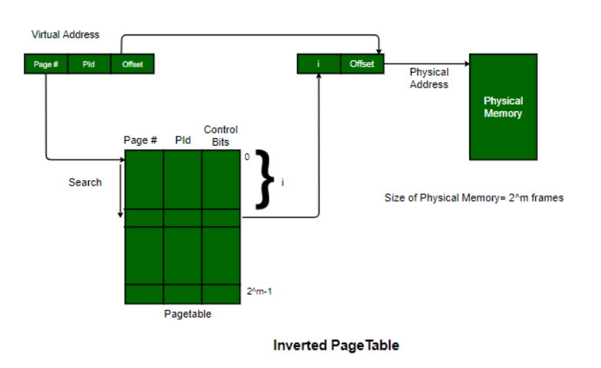
Key Difference in Address Translation
- Page Table: Finds the PFN by looking up the VPN in the process's table.
- Inverted Page Table: Finds the PFN by searching the single, global table for the matching PID/VPN pair, then uses that PFN.
Q. What is meant by Fragmentation, Explain Buddy Systems Fragmentation in detail?
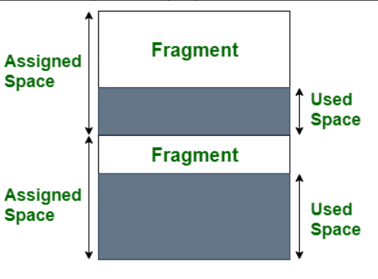
Fragmentation is the division of memory or storage into smaller, often non-contiguous, blocks, leading to unused space. In an operating system, it occurs when files or processes are loaded and unloaded, leaving behind small gaps that are too small for new processes. The buddy system is a memory allocation technique that addresses fragmentation by dividing free memory into blocks of power-of-two sizes, which can be split or merged to satisfy requests and minimize external fragmentation.
What is fragmentation?
- Definition: In computing, fragmentation is the process where memory or disk space is divided into scattered, non-contiguous blocks.
- Cause: It is an inevitable byproduct of loading and unloading processes, which causes free memory to be broken into small, unusable pieces.
- Result: This leads to memory being wasted or "fragmented" because a new process might not fit into the available fragmented space, even if the total free memory is sufficient.
- Types:
  - External fragmentation: Occurs when free memory is broken into many small, scattered blocks, making it impossible to allocate a large contiguous block for a process.
  - Internal fragmentation: Happens when a process is allocated a larger block of memory than it needs. The unused portion of that allocated block is wasted.
The buddy system
- Core idea: The buddy system is a dynamic memory allocation algorithm that manages free memory by keeping it in blocks of specific sizes. The most common version is the binary buddy system, which uses block sizes that are powers of two ($2^{k}$).
- How it works:
  - Initial division: The total memory is divided into a set of blocks, each with a size that is a power of two.
  - Allocation: When a process requests memory, the system finds the smallest available block that is large enough to hold it.
  - Splitting: If the smallest available block is larger than the requested size, it is repeatedly split into two equal "buddy" halves until a block of the required size is created.
  - Deallocation: When a process releases a block, it is returned to the free list. If its "buddy" block is also free, the two are merged into a single, larger block.

- Fragmentation control: The buddy system effectively controls external fragmentation by merging blocks when they become free, which reduces the amount of scattered, unusable free space. However, it can still suffer from internal fragmentation because the smallest block it can allocate is still a power of two, and a process might not use all of that allocated space.
Q. Define and Explain Thrashing
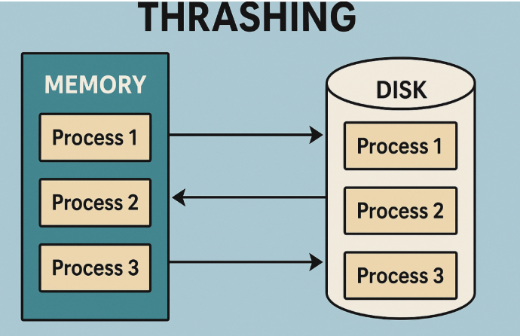
Thrashing in computing is a severe performance problem where an operating system spends most of its time swapping data (pages) between fast RAM and slow disk storage (virtual memory) instead of executing processes, caused by insufficient physical memory or too many processes, leading to system unresponsiveness and drastically reduced throughput. It's like trying to work at a tiny desk, constantly shuffling papers (pages) to find what you need, but never actually getting work done.

How Thrashing Happens
- High Demand: A system tries to run many processes (high degree of multiprogramming) or processes that need more memory than available.
- Page Faults: When a needed data page isn't in RAM, a "page fault" occurs, requiring the OS to load it from the disk.
- Excessive Swapping: To make space, the OS swaps out an old page. If the new process immediately needs the page that was just swapped out (or another not in RAM), the cycle repeats rapidly.
- CPU Wasted: The CPU spends most of its time managing these swaps (disk I/O) rather than running application instructions, causing a performance collapse.
Causes
- Insufficient RAM: Not enough physical memory to hold the active data (working sets) of running programs.
- High Multiprogramming: Too many processes competing for limited memory.
- Poor Locality of Reference: Processes accessing memory non-localized, requiring frequent new pages.
Symptoms & Effects
- Slow system response, freezing.
- Excessive disk activity (high page fault rate).
- High CPU utilization, but low actual work done (low throughput).
Solutions
- Add more RAM (Increase physical memory).
- Reduce multiprogramming (Limit concurrent processes).
- Tune virtual memory settings (Optimize paging file size).
- Improve application memory management.

Q. Explain following placement strategies: First Fit, Best Fit, Next Fit and Worst Fit.
The four memory placement strategies are: First Fit, which allocates the first available partition that is large enough; Best Fit, which allocates the smallest possible partition that fits the process; Worst Fit, which allocates the largest available partition; and Next Fit, which is a variation of First Fit that starts searching from the last allocation point instead of the beginning. Each strategy has trade-offs between speed, memory efficiency, and fragmentation.
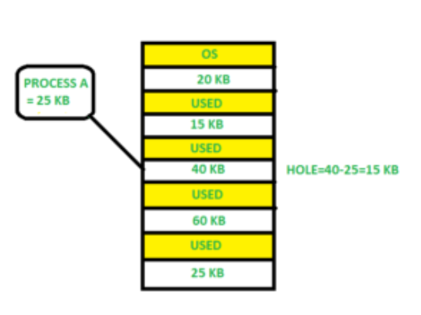
First Fit

- How it works: Scans memory from the beginning and allocates the first free block that is large enough for the process.
- Pros: Simple and fast because it stops searching as soon as a suitable block is found.
- Cons: Can leave behind many small, unusable fragments of memory, potentially leading to external fragmentation.
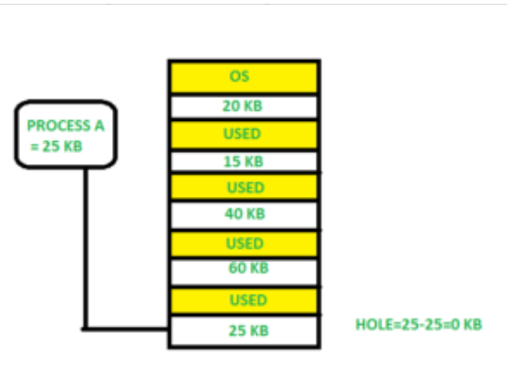
Best Fit

- How it works: Scans the entire list of free blocks and allocates the smallest partition that can still accommodate the process.
- Pros: Minimizes wasted space by leaving the smallest possible fragment.
- Cons: Slower than First Fit because it must search all free blocks. It can also create many very small, unusable fragments that are too small for future processes.
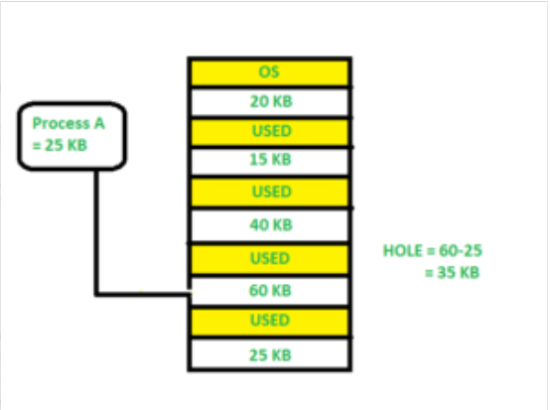
Worst Fit

- How it works: Scans the entire list of free blocks and allocates the largest available one.
- Pros: Intended to leave a large remaining free block that might be useful for future larger processes.
- Cons: It can break up large blocks into smaller, potentially unusable ones. It is often considered the worst in terms of efficiency because it can lead to significant internal fragmentation, as shown in this YouTube video.
Next Fit
- How it works: Like First Fit, it looks for the first suitable block, but it starts its search from where the last allocation was made, rather than from the beginning of memory.
- Pros: Often faster than First Fit because it avoids searching the initial part of memory that has already been processed. It can also reduce the creation of small, unusable fragments at the beginning of memory.
- Cons: Can have a similar problem to First Fit where small fragments are left behind.
Comparison of Partition Allocation Methods:
Sl.No. | Partition Allocation Method | Advantages | Disadvantages
1. | Fixed Partition | Simple, easy to use, no complex algorithms needed | Memory waste, inefficient use of memory resources
2. | Dynamic Partition | Flexible, more efficient, partitions allocated as required | Requires complex algorithms for memory allocation
3. | Best-fit Allocation | Minimizes memory waste, allocates smallest suitable partition | More computational overhead to find smallest split
4. | Worst-fit Allocation | Ensures larger processes have sufficient memory | May result in substantial memory waste
5. | First-fit Allocation | Quick, efficient, less computational work | Risk of memory fragmentation

Q.Explain any two scheduling algorithm with suitable example.
Here are explanations of four common CPU scheduling algorithms used in operating systems, each with a suitable example.
1. First-Come, First-Served (FCFS)
FCFS is the simplest scheduling algorithm, where processes are executed in the exact order they arrive in the ready queue, much like a queue at a grocery store. It is a non-preemptive algorithm, meaning a process runs until it completes its CPU burst or requests I/O, without interruption.
- Advantage: Simple and easy to understand/implement.
- Disadvantage: Suffer from the "convoy effect," where a short process gets stuck waiting behind a very long one, leading to poor average waiting times.
Example:
Process | Arrival Time | Burst Time (ms)
P1 | 0 ms | 4 ms
P2 | 1 ms | 3 ms
P3 | 2 ms | 2 ms
Execution Order: P1, P2, P3.
- P1 runs from 0ms to 4ms. (Waiting Time: 0ms)
- P2 arrives at 1ms but waits until 4ms. Runs from 4ms to 7ms. (Waiting Time: 4ms - 1ms = 3ms)
- P3 arrives at 2ms but waits until 7ms. Runs from 7ms to 9ms. (Waiting Time: 7ms - 2ms = 5ms)
2. Shortest Job First (SJF)
SJF is a non-preemptive algorithm that selects the process with the smallest CPU burst time to execute next, assuming the burst time is known in advance. This strategy is optimal for minimizing the average waiting time.
- Advantage: Minimizes average waiting time.
- Disadvantage: Can lead to starvation of longer processes if short processes keep arriving, and it's hard to predict the exact burst time in a real system.
Example:
Process | Arrival Time | Burst Time (ms)
P1 | 0 ms | 8 ms
P2 | 1 ms | 4 ms
P3 | 2 ms | 9 ms
P4 | 3 ms | 3 ms
Execution Order: P1, P4, P2, P3 (At time 0, only P1 is available. When P2, P3, P4 arrive, the shortest jobs P4 and P2 are prioritized after P1 yields or completes its initial time slice if preemptive). For the non-preemptive version:
- P1 runs from 0ms to 8ms (only process at time 0).
- By 8ms, P2, P3, P4 have arrived. P4 (3ms) is the shortest, then P2 (4ms), then P3 (9ms).
- P4 runs from 8ms to 11ms.
- P2 runs from 11ms to 15ms.
- P3 runs from 15ms to 24ms.

3. Round Robin (RR)
Round Robin is a preemptive algorithm designed for time-sharing systems, ensuring fairness among all processes. Each process is given a small, fixed unit of time, called a time quantum or time slice, to execute. If the process does not finish within its quantum, it is moved to the end of the ready queue.
- Advantage: Provides fair CPU allocation and prevents starvation.
- Disadvantage: Performance heavily depends on the time quantum size; a very small quantum causes too many context switches (overhead), while a large one makes it behave like FCFS.
Example: Quantum = 2 ms
Process | Arrival Time | Burst Time (ms)
P1 | 0 ms | 4 ms
P2 | 1 ms | 5 ms
P3 | 2 ms | 6 ms
Execution Order: P1, P2, P3, P1, P2, P3, P2, P3
- P1 runs from 0-2ms (remaining: 2ms).
- P2 runs from 2-4ms (arrived at 1ms; remaining: 3ms).
- P3 runs from 4-6ms (arrived at 2ms; remaining: 4ms).
- P1 runs from 6-8ms (remaining: 0ms, completes).
- P2 runs from 8-10ms (remaining: 1ms).
- P3 runs from 10-12ms (remaining: 2ms).
- P2 runs from 12-13ms (remaining: 0ms, completes).
- P3 runs from 13-15ms (remaining: 0ms, completes).
4. Priority Scheduling
In this algorithm, each process is assigned a priority number, and the CPU is allocated to the process with the highest priority. Priorities can be static or dynamic and can be based on factors like memory requirements or process type. It can be either preemptive or non-preemptive.
- Advantage: Can efficiently manage critical processes by giving them higher priority.
- Disadvantage: Can lead to indefinite blocking or starvation for low-priority processes, a problem often solved using a technique called "aging" (gradually increasing the priority of processes that wait for a long time).
Example: (Non-preemptive, lower number = higher priority)
Process | Arrival Time | Burst Time (ms) | Priority
P1 | 0 ms | 4 ms | 2
P2 | 1 ms | 2 ms | 1
P3 | 2 ms | 1 ms | 3
Execution Order: P1, P2, P3
- P1 runs from 0ms to 4ms (only process at time 0).
- At 4ms, P2 and P3 are in the queue. P2 has higher priority (1 vs 3).
- P2 runs from 4ms to 6ms.
- P3 runs from 6ms to 7ms.
Q. page replacement algorithum and their policies.
i) FIFO ii) LRU iii) Optimal

